

Roll # 20SW01

Name Abdullah Memon

Department Software Engineering

Teacher Dr. Sajida Parveen

20SW01

Quaid-e-Awam University

Of Engineering, Science and Technology Nawabshah

WEB ENGINEERING

Lab Manual 20 SWE

**Introduction:**

Now a day’s Information and Communication Technology (ICT) plays a great role in different fields or areas among thus Health Care System belongs to this. This leads to various studies and researches being conducted to selected health care facilities. It is necessary to ensure a technologically appropriate, equitable, affordable, efficient and environmentally adaptable and consumer friendly system, designed to fully utilize the ICT for the maximum benefit in the health care Industry.

As the world is growing so as the medical industries are also developing in their perspectives. There are thousands of medicines in the market but the dealers are unable to sell all types of medical supplies to the customers and for that customers have to visit more shops in search of their medicines.

Sometimes is has been seen that medicines are not available in entire city but the consumers need those medicines because it is the matter of life and death and they have to travel from city to city in search of that particular medicine.

It’s better to create an online shop where user can easily find the medicines they need. The term ecommerce refers to the business model in which products and services are bought and sold over the internet. In simple terms, in ecommerce, business owners can sell their products online and deliver them to the customer’s doorstep.

Nowadays, ecommerce has drastically replaced the traditional ways of buying and selling products. These products are mainly sold on different type of platforms:

* A brand’s website using shopping carts like Shopify, Magento, Woocommerce, BigCommerce, and more
* Marketplaces like Amazon, Flipkart, Myntra, Ajio and many more
* Social media channels like Facebook, Instagram and Pinterest.

**Proposal:**

This is the proposal to the local medical store located in Nawabshah, Sindh, Pakistan whose owner **Mr. Abdullah Memon** want to increase his traditional medical business into an online medical business to spread its business for the global users. An Online Pharmacy Store known as **Abdullah’s Medical Care Shop (AMCS)** has been introduced in this proposal where Owner **Mr. Abdullah Memon** can add the products that he wants to sell to the world.

This web project is for two types of users one is the “Admin” in other words known as the owner of the shop and the other is the “Customer” both are separated by the different login systems presented in this project. Admin can perform each type of activity including maintain stock, maintain Products, maintain orders, and maintain Customers where Customer has a job to purchase items that he/she wants to.

**Requirements:**

This web project **AMCS** is based on;

* Front-end:
  + HTML and CSS.
* Back-end:
  + JavaScript and PHP.
* Database:
  + MySQL server.
* Execution:
  + XAMP server (Apache and MySQL).

**Use Case Diagram for AMCS**

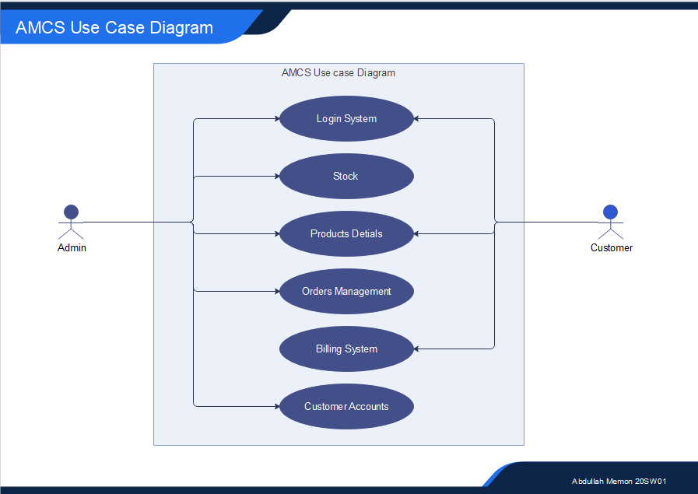

There are two types of user who can use this web application project one is “Admin” and the other is “Customer”

**Admin**:

* **Stocks**: Admin can add, update, and delete stock if necessary.
* **Product Details**: Admin can add new products or can change the details of previously added products and can also delete unnecessary products if necessary.
* **Order Management**: Admin can see the list of new orders that has been placed by the customer and can change the status of the products from pending to deliver or vice versa.
* **Customer Accounts**: Admin can see update and delete the customer accounts their orders as well.

**Customer:**

* **Product Details**: Customer can see only see the details of the products that has been entered by the admin.
* **Billing System**: Customer can select all the items that required and add them to the cart from where he can performs checkouts which leads them to the billing section where customer will see his/her total bills products that has been selected and the billing methods.
* **Customer Accounts**: Customer can create its accounts by registering him/herself in the login section.

**Database:**

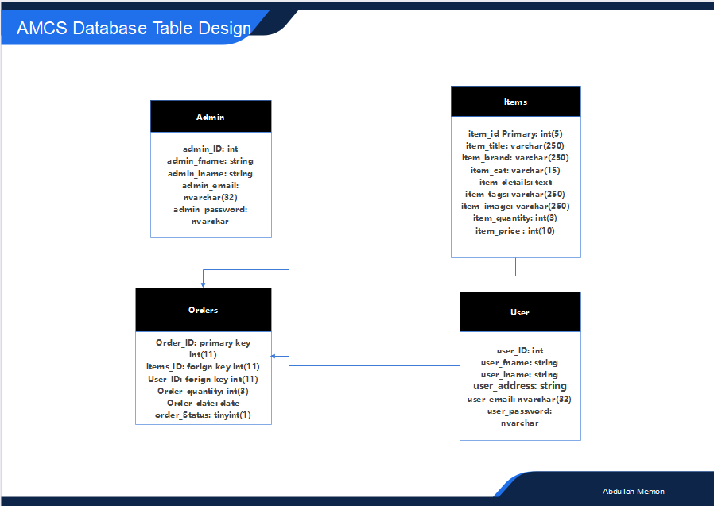

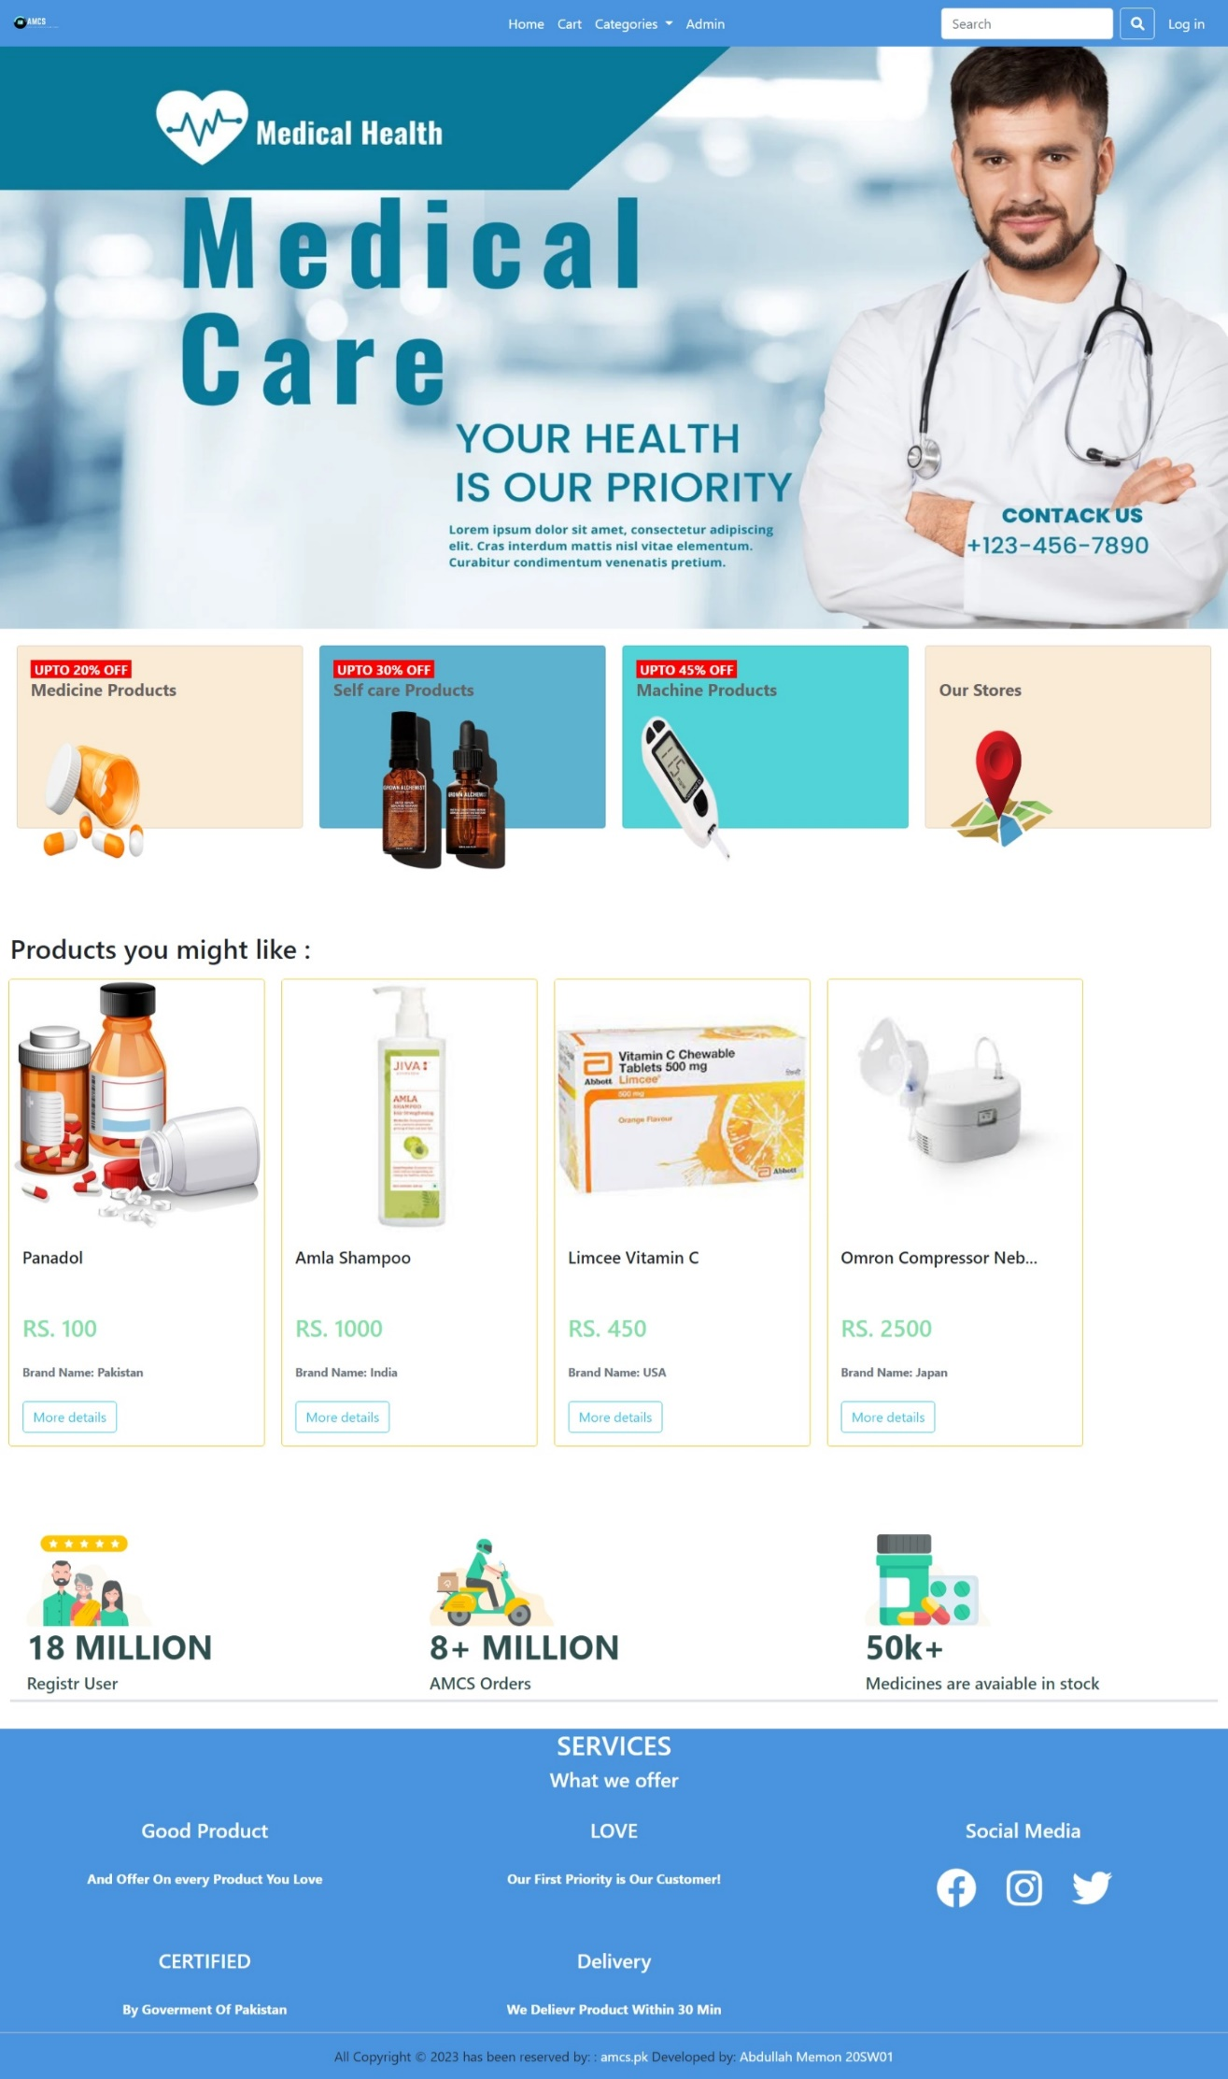**Final Project:**

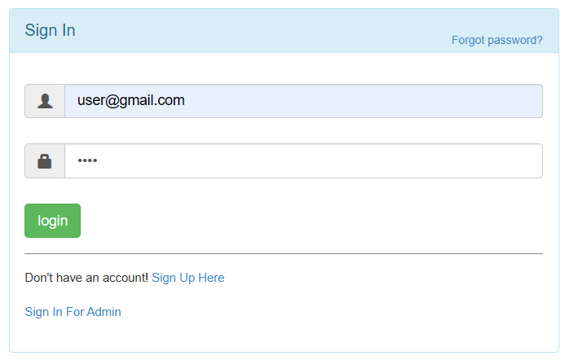**Customer Login**

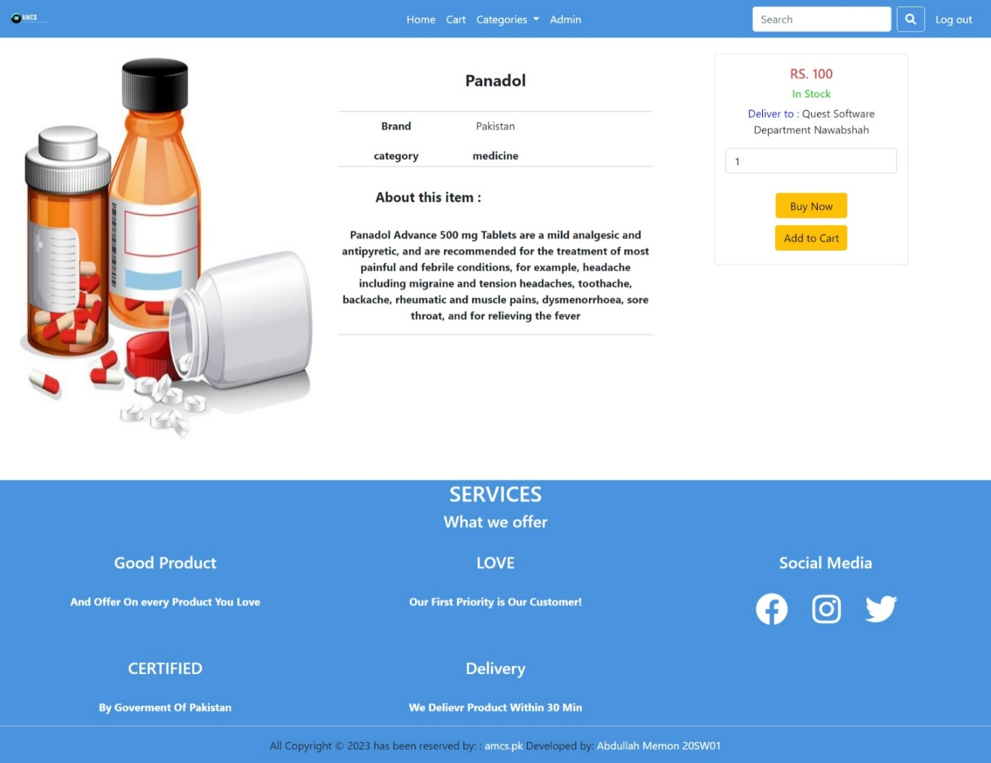**Product Details:**

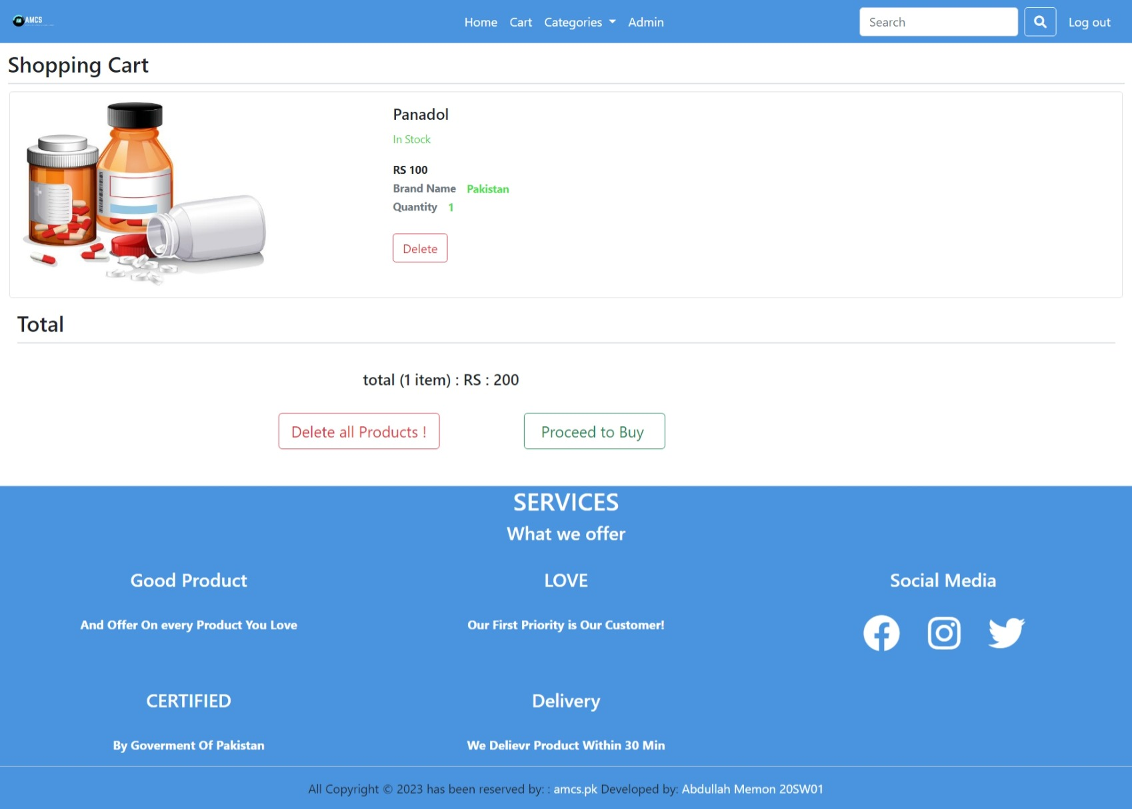**Cart:**

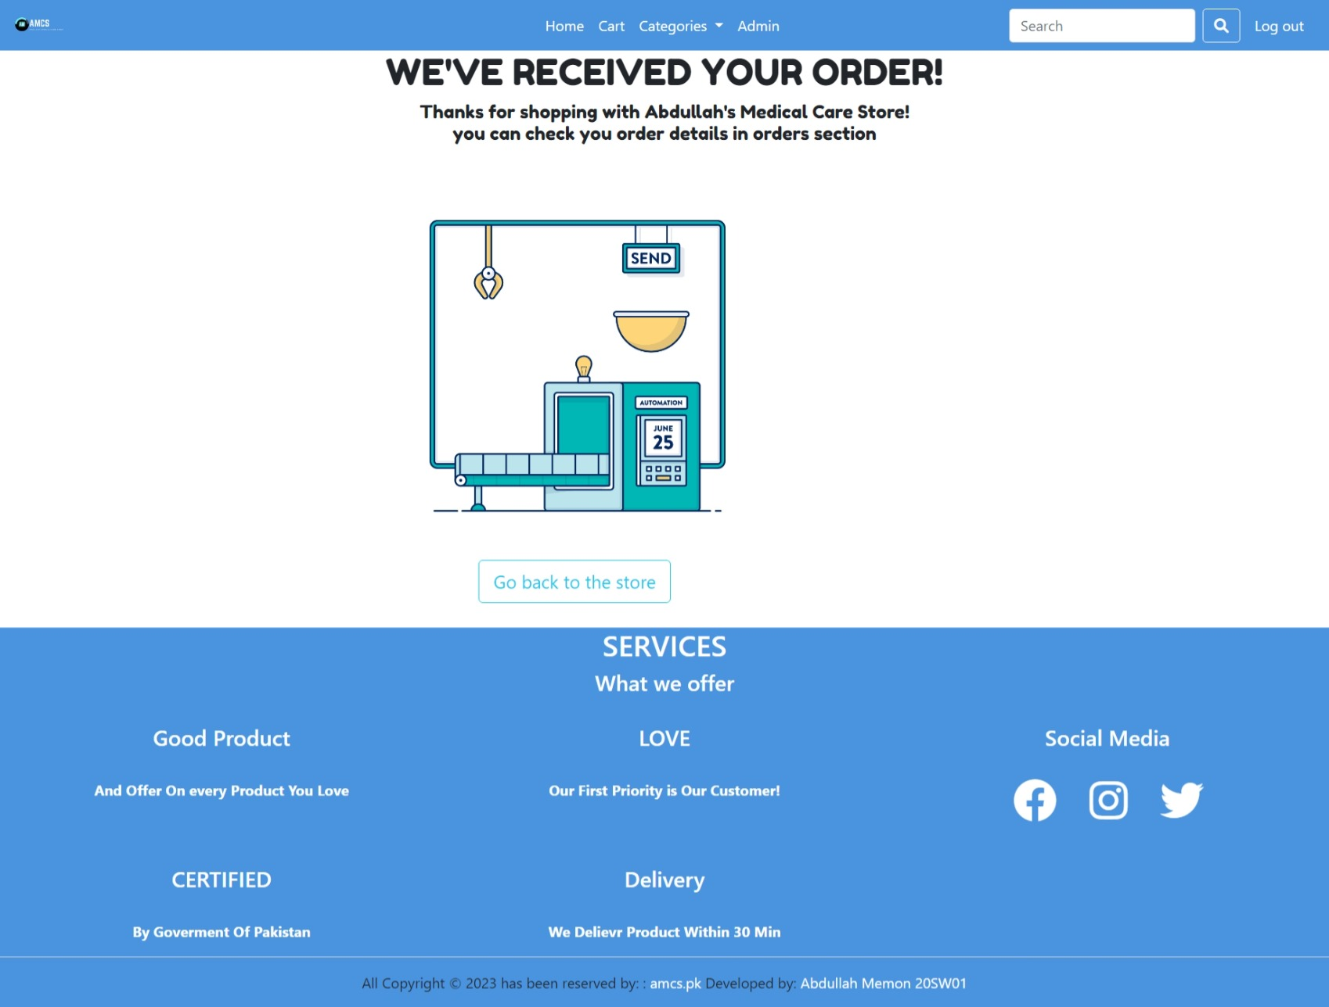**Buy:**

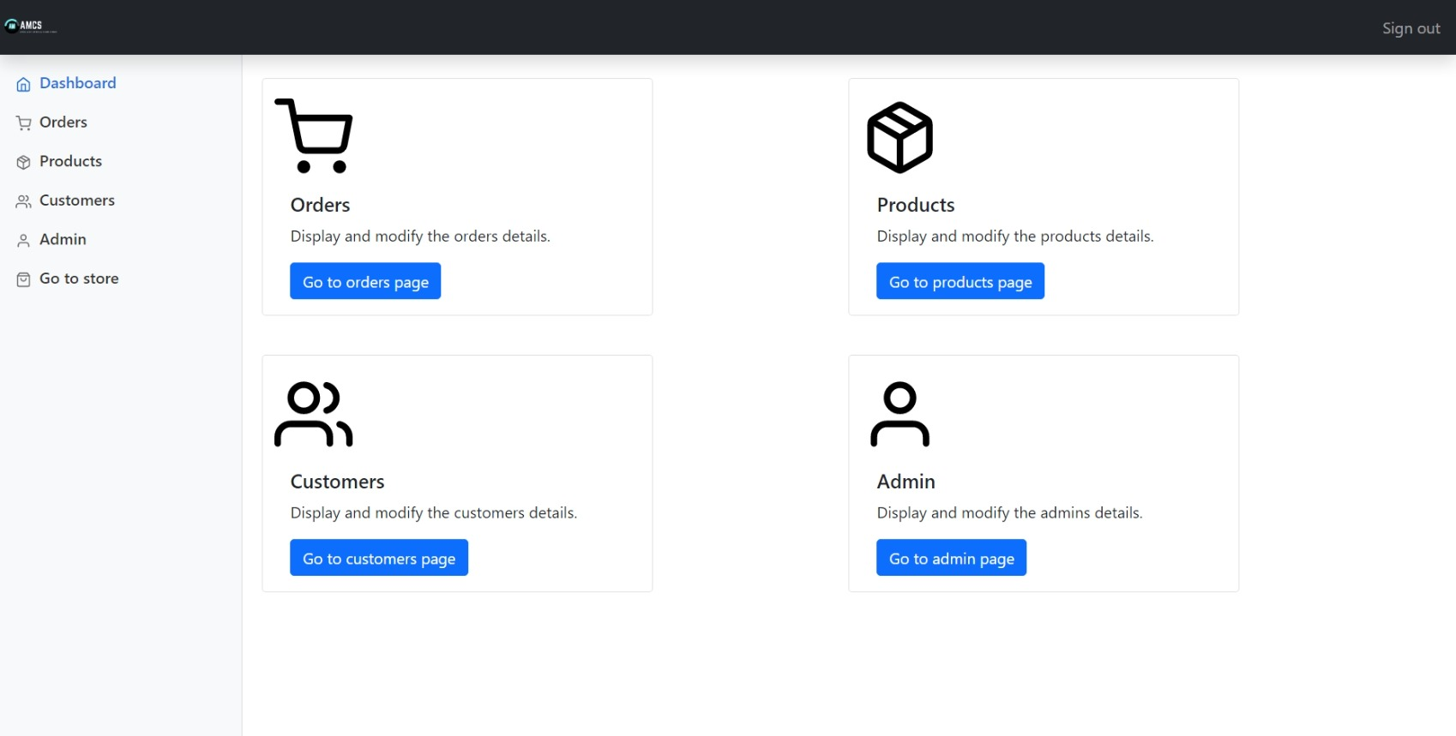**Admin Dashboard:**

**Order Screen:**

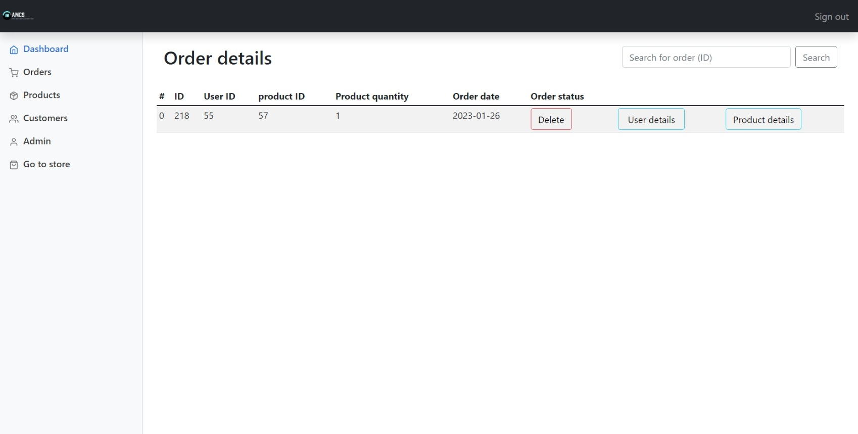

**Products Screen:**

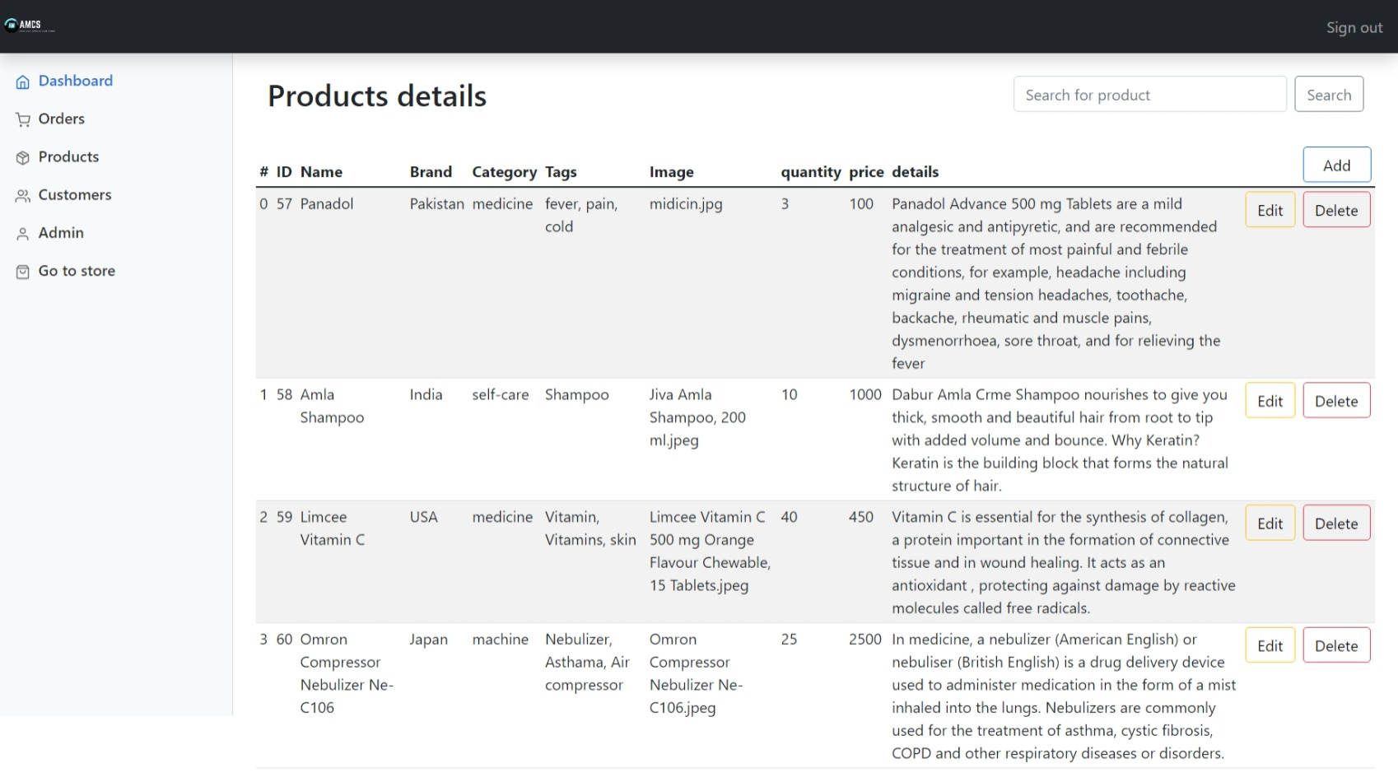

**Customer Accounts Screen:**

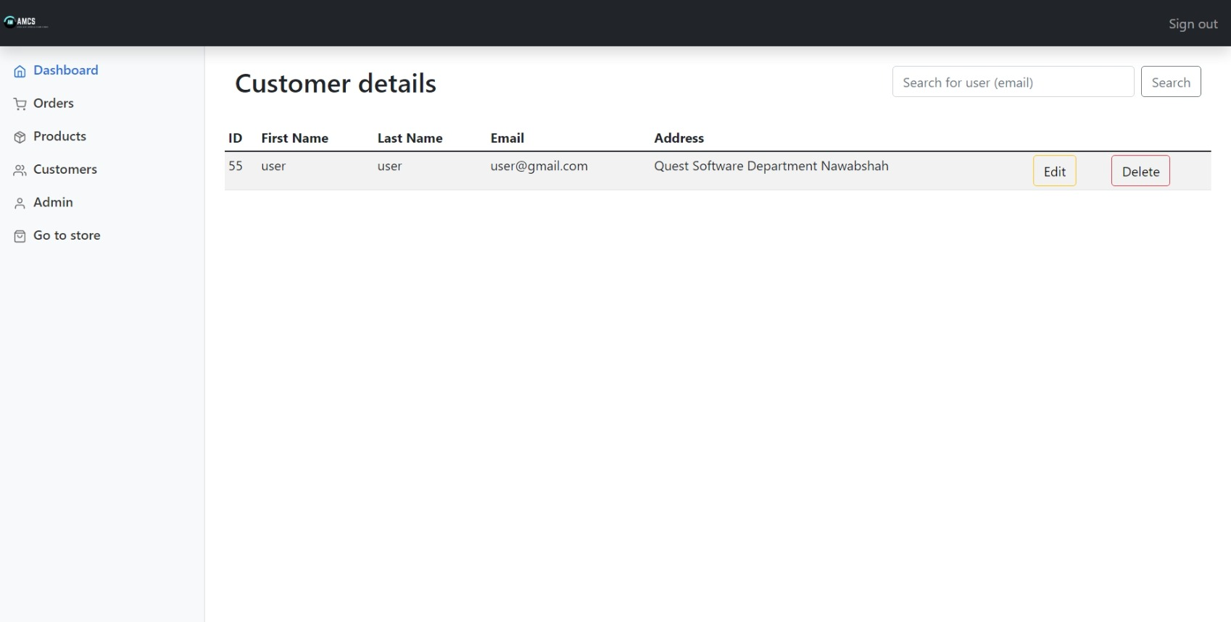

**Admin Accounts Screen:**

